EYFS Why do Christians put a cross in an Easter garden?
What should we know?

Christians believe:
- The cross is a special shape.
- It reminds Christians of when Jesus died on a cross.
- The story has a surprise ending because Jesus is not dead but alive forever.
- Christians celebrate Easter every year at church.
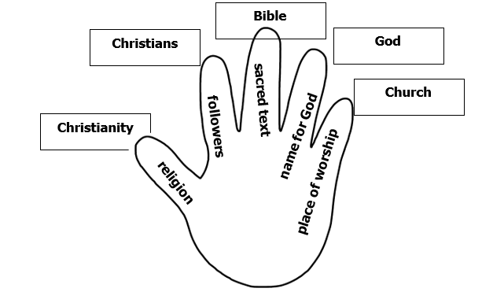
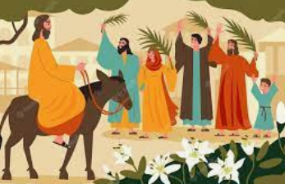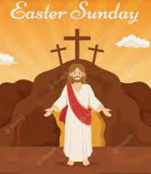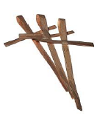
What should we be able to do?
Remember something that happens in the Easter story.

Recognise the cross as a special Christian symbol.

Talk about how Easter is celebrated by Christians.
Vocabulary
God | Christian | Palm Sunday
Jesus | Easter | Hosanna
Bible | cross | symbol
church | save | vicar

