UKS2 Why is the Gospel such good news for Christians?
Prior learning: Christians are followers of Jesus, the saviour of the world. He died but came back to life.
A cross reminds Christians of his sacrifice, but is also a sign of commitment and God’s love.
Jesus told parables to teach about God’s Kingdom and the right way to live. Christians serve others as a response to being saved.
God offers us forgiveness.
The Holy Spirit reminds Christians God is always with them. He gives them strength.

What should we know?
Remember, to Christians, Jesus is good news.
Christians believe:
- Jesus is the saviour of the world. This is good news.
- The Gospels are the books of Matthew, Mark, Luke and John. They are found in the Bible and tell the stories of Jesus.
- Christians live by the Bible and by the things Jesus said.
- The teachings of Jesus have authority in their life.
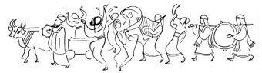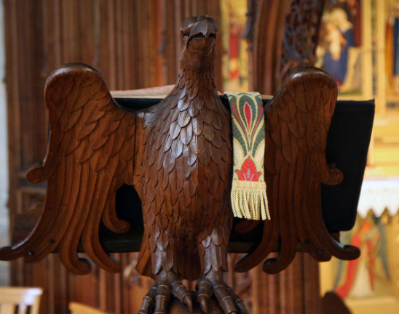

What should we be able to do?
Give examples from the Gospels of how Jesus was good news to people.
Use the right religious words to describe and compare what may happen in a church when the Gospels are read.
Link Christian belief in Jesus as God’s Son to the stories which come from the Gospel.
Explain why a Christians today would describe Jesus as good news.

In the Church of England the Gospel is read from a lectern.

Angel Gabriel tells the shepherds: I am bringing you good news of great joy for all the people.

T
Thgehe

Matthew Mark Luke John
What words should we understand and be able to use?
Gospel | A word that means good news or good story.  It also refers to the four books of the Bible which tell the stories of Jesus. | Lectern | In Anglican churches the Bible is read from the lectern.
Annie Vallotton | The best selling illustrator of all time, Annie drew the illustrations for  the Good News Bible.

