LKS2 Is the cross a symbol of love, sacrifice or commitment for Christians?
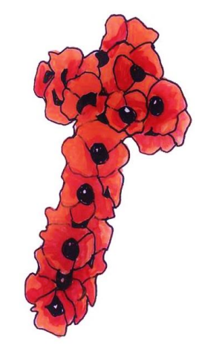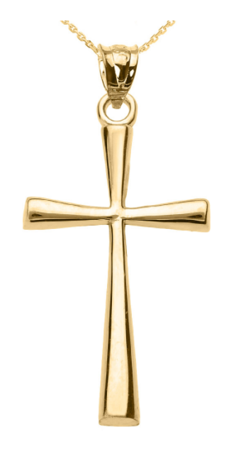
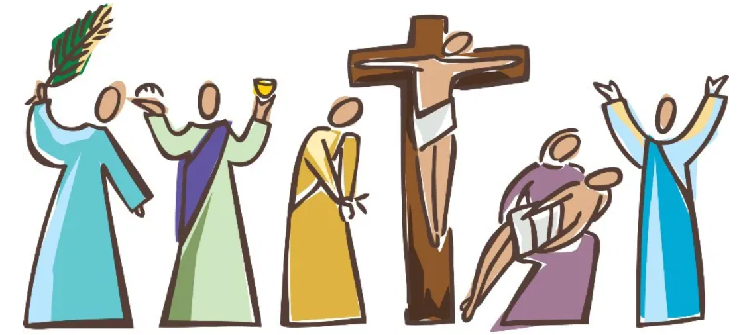
Prior learning: Christians are followers of Jesus, the saviour of the world. He died but came back to life.
Jesus told parables to teach about God.
Christians pray to God and worship him in different ways. God offers us forgiveness.
The Holy Spirit reminds Christians God is always with them.

What should we know?
Remember the Christian cross looks different across the world.
Christians believe:
- Jesus was to put to death on a cross. This was a sacrifice for the whole world so everyone has the chance to live in heaven after they die.
- God loves us so much we are worth the sacrifice Jesus made.
- Wearing a cross is a symbol of commitment to following Jesus.
The stories of Jesus death are told in church during holy week.
What should we be able to do?
Explain the link between Remembrance and the Christian concept of sacrifice.
Describe what a Christian might learn from one of the stories of Holy Week.
Describe how Christians use crosses to show they are Christians and how the cross makes them feel.

T
Thgehe
Jerusalem The Last Supper Arrest Crucifixion Burial Resurrection

What words should we understand and be able to use?
Sacrifice | Christians believe Jesus made a great sacrifice, coming from Heaven to be born on Earth and die on a cross. | Crucifix | A crucifix is a cross with a picture or image of Jesus on it.
Holy week | Holy week begins with Palm Sunday, and includes the Last Supper, arrest, trial, crucifixion, burial and resurrection of Jesus.

