**UKS2 What is holiness for Jewish people: a place, a time, an object or something else?**

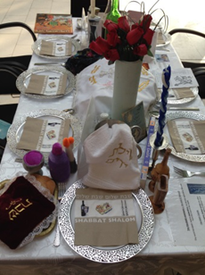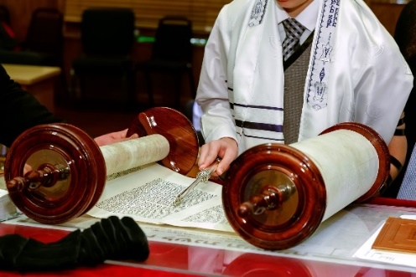

**What should we know?**

Jewish people believe:

* God is holy.
* God gives commands to his people to make them holy, to live a holy life and keep to a holiness code.
* God’s name itself is holy. Jewish people use an alternative for the word God e.g. Ha shem – the name, or G - D.
* Shabbat is a holy time.
* Being Barmitzvah/Batmitzvah does not make someone holy but it makes a Jewish person responsible to God for their religious lives.

**Prior learning**

Mitzvahs (good deeds) are important.

Shabbat is a day of rest.

At New Year God gives people a chance to put things right.

The Torah is an important book.

The Exodus story.

There is a covenant between God and the Jewish people.

**What should we be able to do?**

*Explain what the burning bush story in Exodus teaches about holiness.*

*Explain in what way Shabbat is holy and how Jewish families mark its beginning and ending.*

*Give examples of what the Torah says about living a holy life.*

**You shall be holy, for I the Lord your God am holy. Leviticus 19 v.2**

**What words should we understand and be able to use?**

|  |  |  |  |
| --- | --- | --- | --- |
| **Ner Tamid** | The eternal flame, it burns in front of the Holy Ark in a synagogue as a reminder of God’s presence. | **Bar Mitvah**  **Bat Mitvah** | Children become responsible for their own religious lives. Boys become ‘bar mitzvah’ at 13. Girls become ‘bat mitzvah’ at 12. |
| **Shabbat** | The Jewish day of rest (Saturday). |  |  |