UKS2 How does the Triple Refuge help Buddhists in their journey through life?
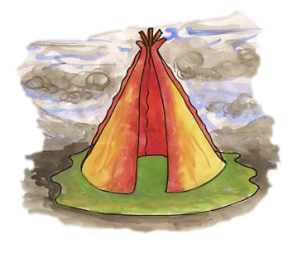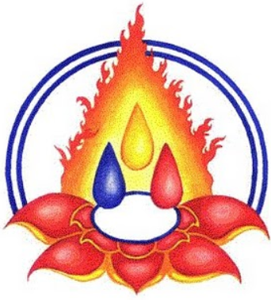
What should we know?
The triple refuge support Buddhists on their journey to enlightenment
Buddhists believe:
- Buddha is the guide. They revere but do not worship Buddha; they take ‘refuge’ in him as their guide towards enlightenment.
- Dharma is the path (the teaching). It shows Buddhists the way to travel to reach enlightenment. It is a safe, well laid path which they can follow for themselves.
- Dharma includes rules for right living and teaching on how to avoid bad actions.
- Sangha are the travelling companions, the Buddhist community.
- The Five precepts help you to live ethically and morally good lives.
Prior
learning
Following the Buddha’s teachings (the eightfold path) allows every human to achieve enlightenment and end suffering.

What should we be able to do?
Show how Buddhists express their belief that the Buddha is a refuge and guide.
Explain how the Buddha’s teachings (dharma) help Buddhists journey along the path.
Use the right religious words to describe the practices and experiences of Buddhists belonging to the Sangha, both lay and monastic.
Explain how members of the Sangha support each other at the festival of Wesak.

The Triple Gem

What words should we understand and be able to use?
Buddha | Buddha is a title given to Siddhatta Gotama; it means ‘enlightened’ or ‘awakened’ one. | Triple Gem | Gold symbolises Buddha and his wisdom, Blue symbolises the Dharma (Buddha’s teaching) and Red symbolises the Sangha (Buddhist community).
Dharma | Is the path to enlightenment made of the Buddha’s teachings. | Five Moral  Precepts | a commitment to try leaving behind certain behaviours, and take on others as a way of developing RIGHT ACTION or conduct which will advance them spiritually along Buddha’s Eightfold Path to enlightenment.
Sangha | Sangha means ‘friendly or harmonious community’. It may be lay or monastic. | Wesak | Wesak celebrates the Buddha's birthday and, for some Buddhists, also marks his enlightenment and death. It is also called Buddha Day.

